13. Chemical Integration: Hormones and the Endocrine System *(RHM: Chapter 42)*

______________________________________________________________________________

I. Integration of Physiological and Behavioral Functions *(994-997)*

A. Role of the Nervous System

B. Role of the Endocrine System

1. Endocrine glands

2. Hormones

3. Target organs

C. Basic Principles of Endocrine Function

1. Function at low concentrations

2. Response determined by target organ

3. Antagonistic hormones provide precise regulation

II. Regulation of Body Chemistry and Physiology: Role of Hypothalamus *(1001-1005*)

A. Functions

B. Monitoring and Control in the Brain

1. The hypothalamus

2. The portal system

3. The anterior pituitary

C. Stimulating Hormones

D. Principle of Negative Feedback

III. Endocrine Systems Not Under Direct Hypothalamic Control *(1005-1011)*

A. Introduction

B. Digestion

1. Hormones of the stomach and intestine

2. Hormone action

C. Endocrine Functions of the Pancreas

1. Structure of pancreatic tissue

2. Insulin

3. Glucagons

D. Adrenal Medulla: Adrenalin and noradrenalin

E. Parathyroids: Parathyroid hormone and mineral balance

IV. Regulation of Development *(1011-1012)*

A. Life Cycles and Regulation

B. Control of Metamorphosis in Insects

1. Insect life cycles

2. Brain anatomy and endocrine glands

3. Antagonistic hormones controlling development

C. Control of Metamorphosis in Amphibians

1. Changes in metamorphosis

2. Hormonal control of metamorphosis

3. Specificity of responses

13-1

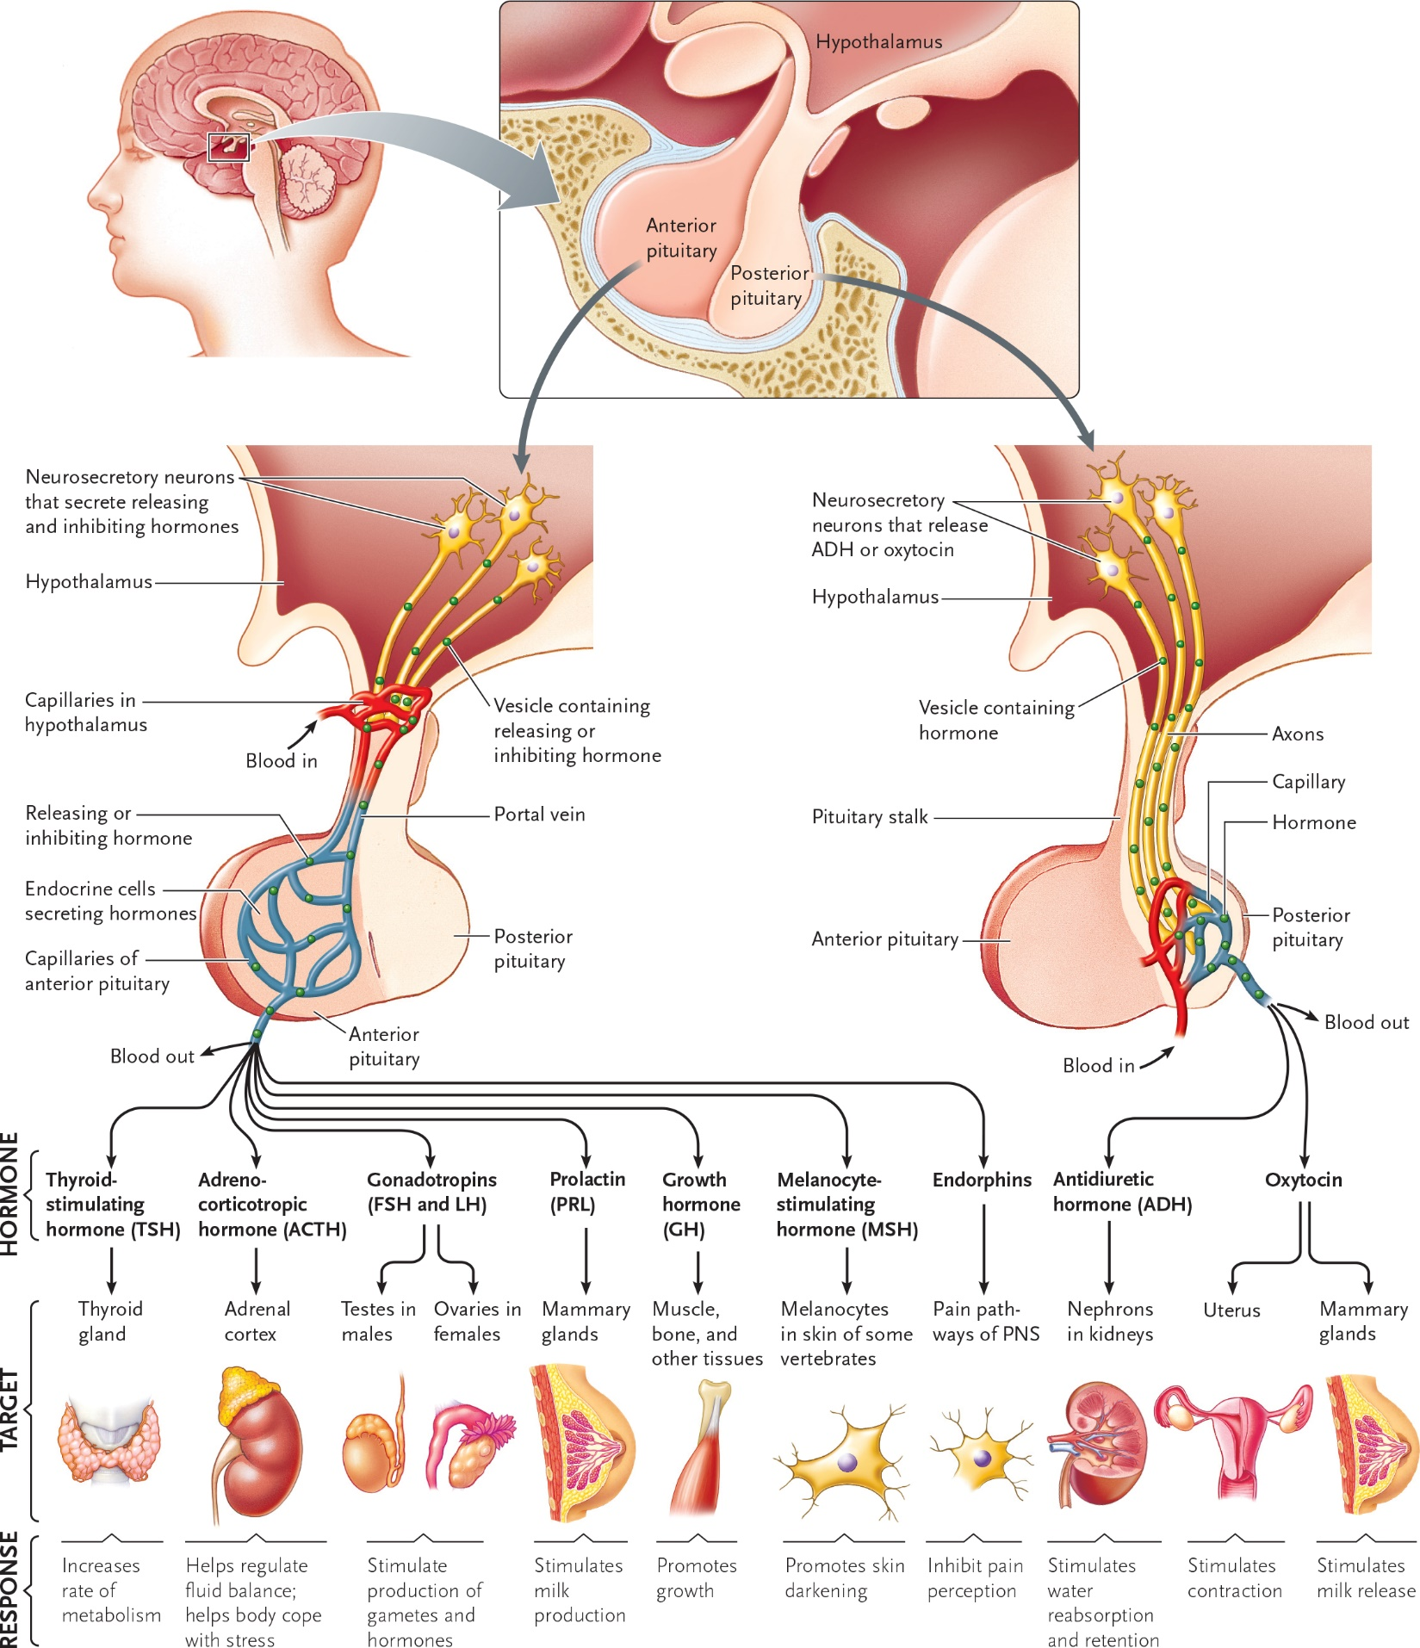

13-2

**NEGATIVE FEEDBACK**

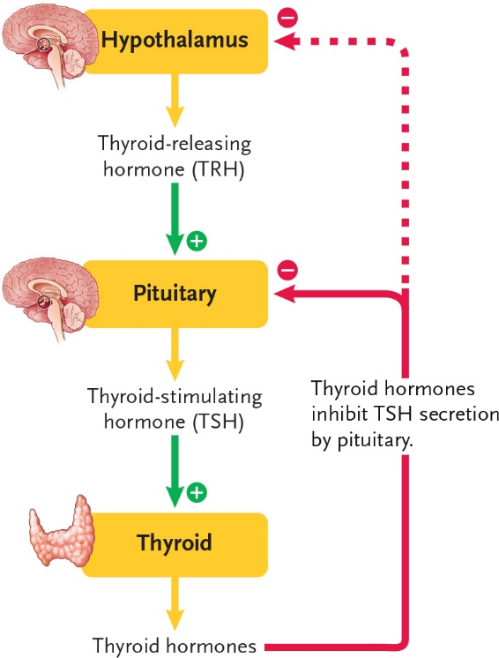

__________________________________________________________________________

**NEGATIVE & POSITIVE FEEDBACK**

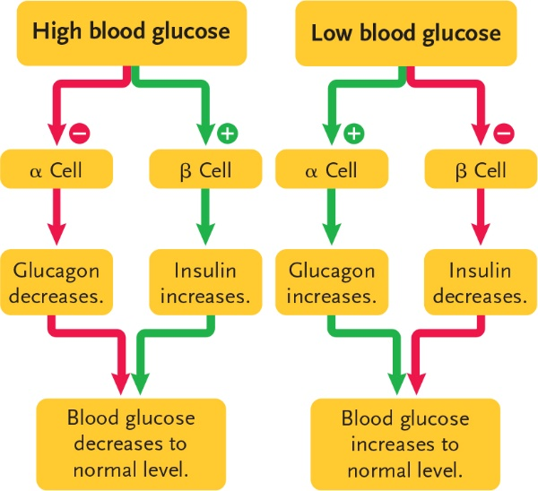

13-3

